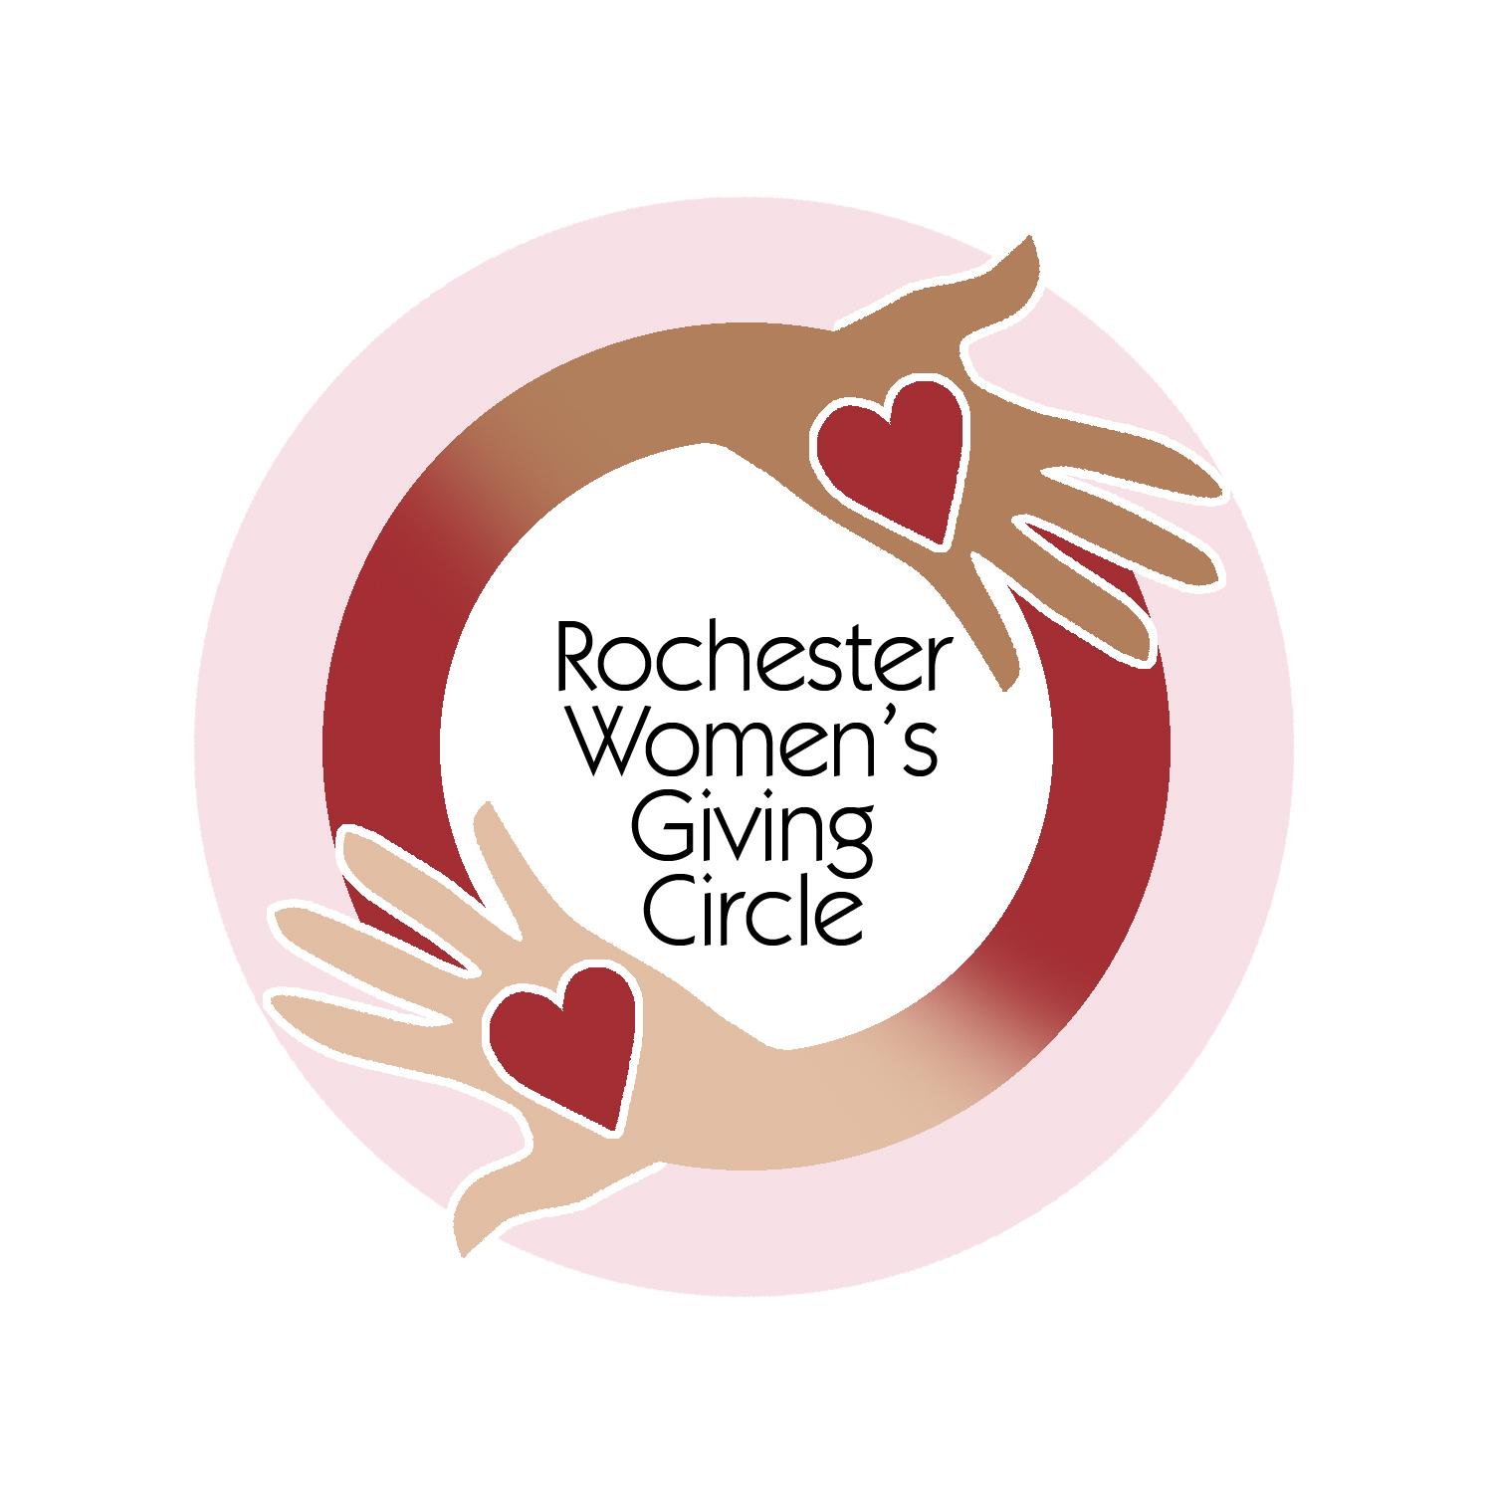 | Rochester Women’s Giving Circle  Supporting women and girls on their journey to economic independence

I would like to join the Rochester Women’s Giving Circle with my gift of $

(The minimum annual contribution is $1,050.)

Name

Address

City, State Zip

Phone

Email

Pledge Information: (Check all that apply.)
☐ I am enclosing a check payable to Rochester Area Community Foundation with “RWGC” on the memo line.
☐ Please transfer my membership contribution from my Community Foundation Advised Fund or Charitable Checking Account.
☐ I wish to make my donation with a credit card. (Minimum contribution is $1,080 to cover the additional credit card processing fee.)
☐ I will contact the Community Foundation to arrange payment with a credit card.
☐ I will donate online through the Community Foundation’s website (click here).
☐ I would like to be a Sustaining Member. Renew my annual pledge automatically.
☐ My gift will be matched by (company/family/foundation)
☐ I am not able to contribute at this time, but plan to donate by December 31st.
Please mail this form (and your check, if enclosed) to:
Rochester Area Community Foundation
500 East Avenue
Rochester, NY 14607
Information for the Community Foundation:
☐ Check here if you prefer not to be listed in the Community Foundation’s Donor Listing.
☐ Check here if you prefer not to receive the Community Foundation’s mailings.

